

<https://www.brandcrowd.com/maker/logo/university-emblem-lettermark-91184#popup-colorpalette>

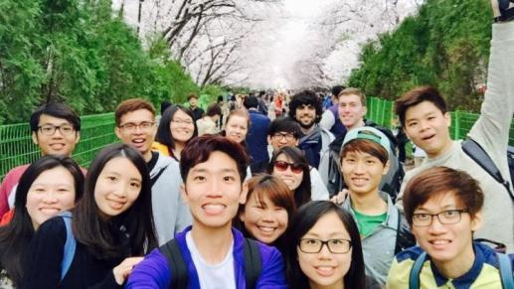

<https://cdn-image.hipwee.com/wp-content/uploads/2016/06/hipwee-3_0-750x422.jpg>

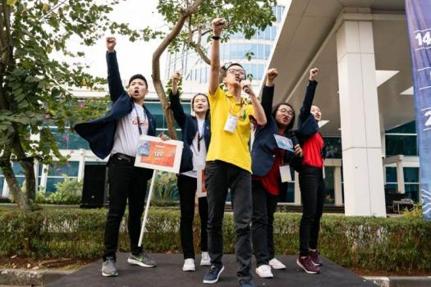

<https://asset.kompas.com/crops/ACjg-Zo_jn9cwAFijVLBxMqW3kQ=/42x53:956x662/750x500/data/photo/2018/08/16/90021123.jpg>

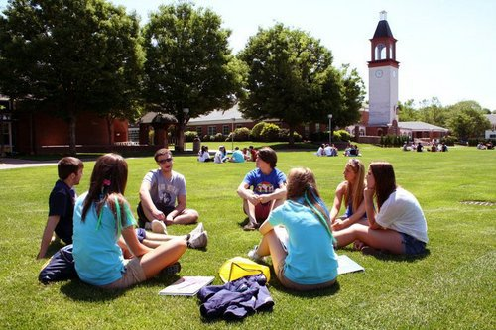

<https://cdn-brilio-net.akamaized.net/video/2017/08/02/139318/659011-1.jpg>

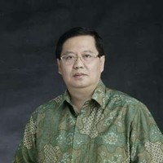

<https://media-exp1.licdn.com/dms/image/C4E03AQF1WUdZailxNQ/profile-displayphoto-shrink_200_200/0/1516511273896?e=2147483647&v=beta&t=MDPcqfVqlpktdoCWUC1StR1JcbQUG8uG7oWG0Kkj26Y>

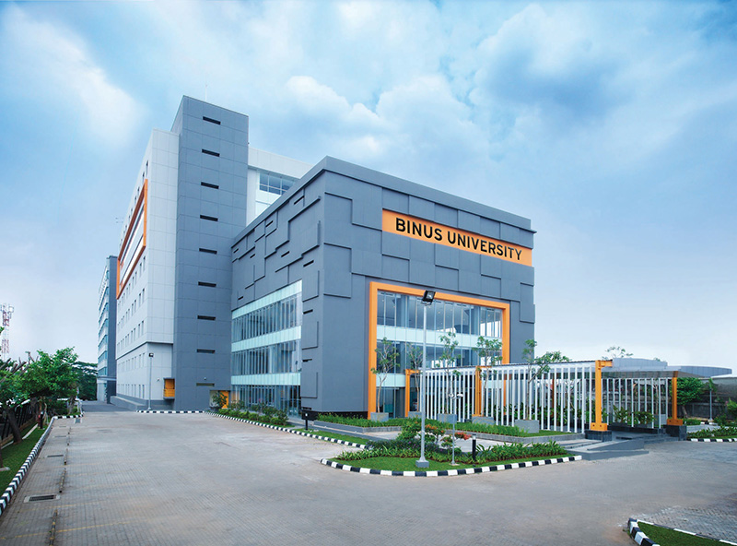

<https://global.binus.ac.id/files/2021/05/BInus-Anggrek.jpg>

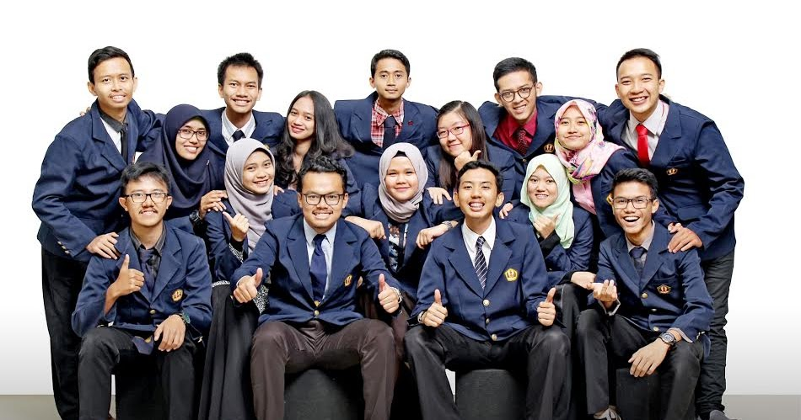

<https://4.bp.blogspot.com/-Uvbnq0nmiNk/WTwtMMmO1YI/AAAAAAAAB2I/j2LN900OmFk-zV59RVc157RcgTy0rB4jACLcB/w1200-h630-p-k-no-nu/cara%2Bmenjadi%2Bmahasiswa%2Bberpertasi.jpg>